BELONGING, BEING & BECOMING

The Early Years Learning Framework for Australia

ISBN 978-642-77872-7

With the exception of the Commonwealth Coat of Arms, the Department’s logo, any material protected by a trade mark and where otherwise noted all material presented in this document is provided under a Creative Commons Attribution 4.0 International (http://creativecommons.org/licenses/by/3.0/au/) licence.
The details of the relevant licence conditions are available on the Creative Commons website (accessible using the links provided) as is the full legal code for the CC BY 4.0 International (http://creativecommons.org/licenses/by/4.0/legalcode).
The document must be attributed as the (The Early Years learning Framework for Australia).

Reproduced by the Australian Government Department of Education and Training. for the Council of Australian Governments.

Contents
Introduction 5
A Vision for Children’s Learning 7
Elements of the Framework 9
Children’s Learning 10
early childhood pedagogy 12
Principles 13
Practice 16
LEARNING OUTCOMES FOR CHILDREN BIRTH TO 5 YEARS 22
Outcome 1: Children have a strong sense of identity 23
Children feel safe, secure, and supported 24
Children develop their emerging autonomy, inter-dependence, resilience 25
and sense of agency
Children develop knowledgeable and confident self identities 26
Children learn to interact in relation to others with care, empathy and respect 27
Outcome 2: Children are connected with and contribute to their world 28
Children develop a sense of belonging to groups and communities and 29
an understanding of the reciprocal rights and responsibilities necessary
for active community participation
Children respond to diversity with respect 30
Children become aware of fairness 31
Children become socially responsible and show respect for the environment 32
Outcome 3: Children have a strong sense of wellbeing 33
Children become strong in their social and emotional wellbeing 34
Children take increasing responsibility for their own health and physical wellbeing 35
Outcome 4: Children are confident and involved learners 36
Children develop dispositions for learning such as curiosity, cooperation, 37
confidence, creativity, commitment, enthusiasm, persistence, imagination
and reflexivity
Children develop a range of skills and processes such as problem solving, 38
inquiry, experimentation, hypothesising, researching and investigating
Children transfer and adapt what they have learned from one context to another 39
Children resource their own learning through connecting with people, place, 40
technologies and natural and processed materials
Outcome 5: Children are effective communicators 41
Children interact verbally and non-verbally with others for a range of purposes 43
Children engage with a range of texts and gain meaning from these texts 44
Children express ideas and make meaning using a range of media 45
Children begin to understand how symbols and pattern systems work 46
Children use information and communication technologies to access information, 47
investigate ideas and represent their thinking
Glossary of Terms 48

Bibliography 50

Introduction
This is Australia’s first national Early Years Learning Framework for early childhood educators. The aim of this document is to extend and enrich children’s learning from birth to five years and through the transition to school.
The Council of Australian Governments has developed this Framework to assist educators to provide young children with opportunities to maximise their potential and develop a foundation for future success in learning. In this way, the Early Years Learning Framework (the Framework) will contribute to realising the Council of Australian Governments’ vision that:
“All children have the best start in life to create a better future for themselves and for the nation.” ¹
The Framework draws on conclusive international evidence that early childhood is a vital period in children’s learning and development. It has been developed with considerable input from the early childhood sector, early childhood academics and the Australian and State and Territory Governments.
The Framework forms the foundation for ensuring that children in all early childhood education and care settings experience quality teaching and learning. It has a specific emphasis on play-based learning and recognises the importance of communication and language (including early literacy and numeracy) and social and emotional development. The Framework has been designed for use by early childhood educators working in partnership with families, children’s first and most influential educators.
Early childhood educators guided by the Framework will reinforce in their daily practice the principles laid out in the United Nations Convention on the Rights of the Child (the Convention). The Convention states that all children have the right to an education that lays a foundation for the rest of their lives, maximises their ability, and respects their family, cultural and other identities and languages. The Convention also recognises children’s right to play and be active participants in all matters affecting their lives.
This document may complement, supplement or replace individual State and Territory frameworks. The exact relationship will be determined by each jurisdiction.
More broadly, the Framework supports Goal 2 of the Melbourne Declaration on Education Goals for Young Australians², that:
All young Australians become:
- Successful learners
- Confident and creative individuals
- Active and informed citizens.
The Melbourne Declaration also commits to improved outcomes for Aboriginal and Torres Strait Islander young people and strengthening early childhood education.
The Council of Australian Governments is committed to closing the gap in educational achievement between Indigenous and non-Indigenous Australians within a decade³. Early childhood education has a critical role to play in delivering this outcome.

1 Investing in the Early Years - a National Early Childhood Development Strategy, Council of Australian Governments
2 On 5 December 2008, State, Territory and Commonwealth Ministers of Education meeting as the Ministerial Council on Education, Employment, Training and Youth Affairs, released the Melbourne Declaration on Educational Goals for Young Australians.
3 The Council of Australian Governments – Communique – 3 July 2008. Indigenous Reform – Closing the Gap.
___________________________________________________________________________________
Recognising this, a specific document that provides educators with additional guidance on ensuring cultural security for Aboriginal and Torres Strait Islander children and their families will be developed and made available to educators.
Over time additional resources may be developed to support the application of this Framework

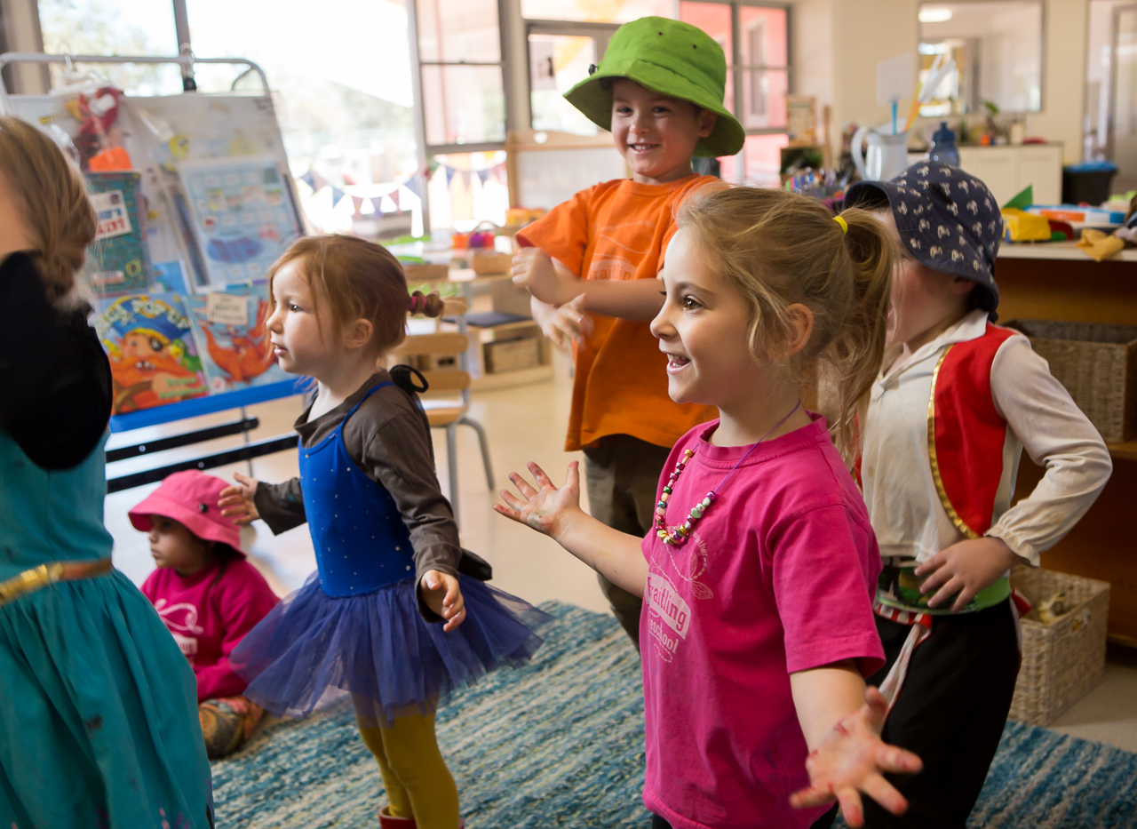

Children:
refers to babies, toddlers and three to five year olds, unless otherwise stated.

Educators:
early childhood practitioners who work directly with children in early childhood settings.

Play-based learning:
a context for learning through which children organise and make sense of their social worlds, as they engage actively with people, objects and representations.

A Vision for
Children’s Learning

All children experience learning that is engaging
and builds success for life.
Fundamental to the Framework is a view of children’s lives as characterised by belonging, being and becoming. From before birth children are connected to family, community, culture and place. Their earliest development and learning takes place through these relationships, particularly within families, who are children’s first and most influential educators. As children participate in everyday life, they develop interests and construct their own identities and understandings of the world.

Belonging
Experiencing belonging – knowing where and with whom you belong – is integral to human existence. Children belong first to a family, a cultural group, a neighbourhood and a wider community. Belonging acknowledges children’s interdependence with others and the basis of relationships in defining identities. In early childhood, and throughout life, relationships are crucial to a sense of belonging. Belonging is central to being and becoming in that it shapes who children are and who they can become.

“You belong in your house with your family” – Dong

Being
Childhood is a time to be, to seek and make meaning of the world.
Being recognises the significance of the here and now in children’s lives. It is about the present and them knowing themselves, building and maintaining relationships with others, engaging with life’s joys and complexities, and meeting challenges in everyday life. The early childhood years are not solely preparation for the future but also about the present.

“If you want to be a mermaid you can imagine” – Jazmine

Becoming
Children’s identities, knowledge, understandings, capacities, skills and relationships change during childhood. They are shaped by many different events and circumstances. Becoming reflects this process of rapid and significant change that occurs in the early years as young children learn and grow. It emphasises learning to participate fully and actively in society.

“When you keep planting plants you become a gardener” – Olivia
The Framework conveys the highest expectations for all children’s learning from birth to five years and through the transitions to school. It communicates these expectations through the following five Learning Outcomes:
- Children have a strong sense of identity
- Children are connected with and contribute to their world
- Children have a strong sense of wellbeing
- Children are confident and involved learners
- Children are effective communicators.

The Framework provides broad direction for early childhood educators in early childhood settings to facilitate children’s learning.
It guides educators in their curriculum decision-making and assists in planning, implementing and evaluating quality in early childhood settings. It also underpins the implementation of more specific curriculum relevant to each local community and early childhood setting.
The Framework is designed to inspire conversations, improve communication and provide a common language about young children’s learning among children themselves, their families, the broader community, early childhood educators and other professionals.

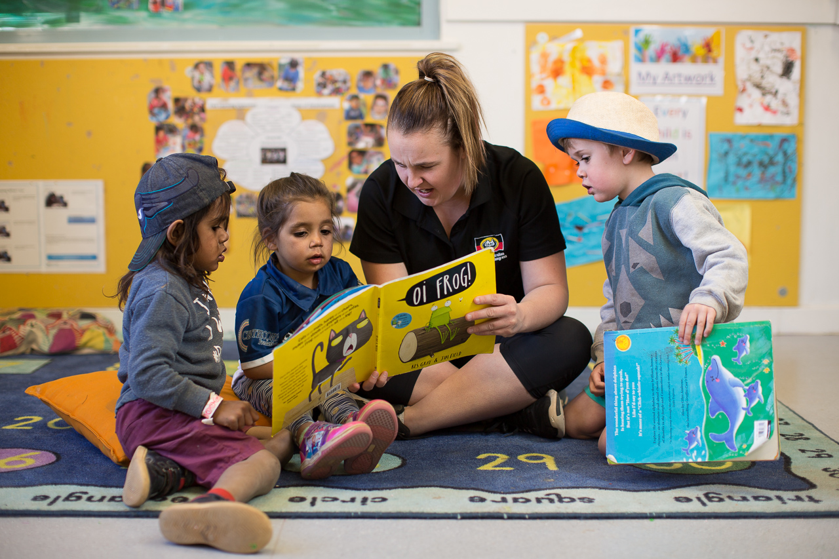

Learning outcome:
a skill, knowledge or disposition that educators can actively promote in early childhood settings, in collaboration with children and families.

Early childhood settings:
long day care, occasional care, family day care, Multi-purpose Aboriginal Children’s Services, preschools and kindergartens, playgroups, creches, early intervention settings and similar services.

Elements of the Framework
The Framework puts children’s learning at the core and comprises three inter-related elements: Principles, Practice and Learning Outcomes (see Figure 1). All three elements are fundamental to early childhood pedagogy and curriculum decision-making.
Curriculum encompasses all the interactions, experiences, routines and events, planned and unplanned, that occur in an environment designed to foster children’s learning and development.
The emphasis in the Framework is on the planned or intentional aspects of the curriculum.
Children are receptive to a wide range of experiences. What is included or excluded from the curriculum affects how children learn, develop and understand the world.
The Framework supports a model of curriculum decision-making as an ongoing cycle. This involves educators drawing on their professional knowledge, including their in-depth knowledge of each child.
Working in partnership with families, educators use the Learning Outcomes to guide their planning for children’s learning. In order to engage children actively in learning, educators identify children’s strengths and interests, choose appropriate teaching strategies and design the learning environment.
Educators carefully assess learning to inform further planning.

Curriculum:
in the early childhood setting curriculum means ‘all the interactions, experiences, activities, routines and events, planned and unplanned, that occur in an environment designed to foster children’s learning and development’. [adapted from Te Whariki]

Pedagogy:
early childhood educators’ professional practice, especially those aspects that involve building and nurturing relationships, curriculum decision-making, teaching and learning.

Children’s Learning
The diversity in family life means that children experience belonging, being and becoming in many different ways. They bring their diverse experiences, perspectives, expectations, knowledge and skills to their learning.
Children’s learning is dynamic, complex and holistic. Physical, social, emotional, personal, spiritual, creative, cognitive and linguistic aspects of learning are all intricately interwoven and interrelated.
Play is a context for learning that:
- allows for the expression of personality and uniqueness
- enhances dispositions such as curiosity and creativity
- enables children to make connections between prior experiences and new learning
- assists children to develop relationships and concepts
- stimulates a sense of wellbeing.
Children actively construct their own understandings and contribute to others’ learning. They recognise their agency, capacity to initiate and lead learning, and their rights to participate in decisions that affect them, including their learning.
Viewing children as active participants and decision makers opens up possibilities for educators to move beyond pre-conceived expectations about what children can do and learn. This requires educators to respect and work with each child’s unique qualities and abilities.
Educators’ practices and the relationships they form with children and families have a significant effect on children’s involvement and success in learning. Children thrive when families and educators work together in partnership to support young children’s learning.
Children’s early learning influences their life chances. Wellbeing and a strong sense of connection, optimism and engagement enable children to develop a positive attitude to learning.
The Learning Outcomes section of the Framework provides examples of evidence of children’s learning and the educator’s role.

Involvement:
is a state of intense, whole hearted mental activity, characterised by sustained concentration and intrinsic motivation. Highly involved children (and adults) operate at the limit of their capacities, leading to changed ways of responding and understanding leading to deep level learning. (adapted from Laevers 1994)

Dispositions:
enduring habits of mind and actions, and tendencies to respond in characteristic ways to situations, for example, maintaining an optimistic outlook, being willing to persevere, approaching new experiences with confidence. (Carr, 2001)

Elements of the Early Years Learning Framework
This diagram shows the relationship between learning outcomes, principles and practice which centres on children’s learning. The three themes of Belonging, Being and Becoming are contained overlapping all of these elements.

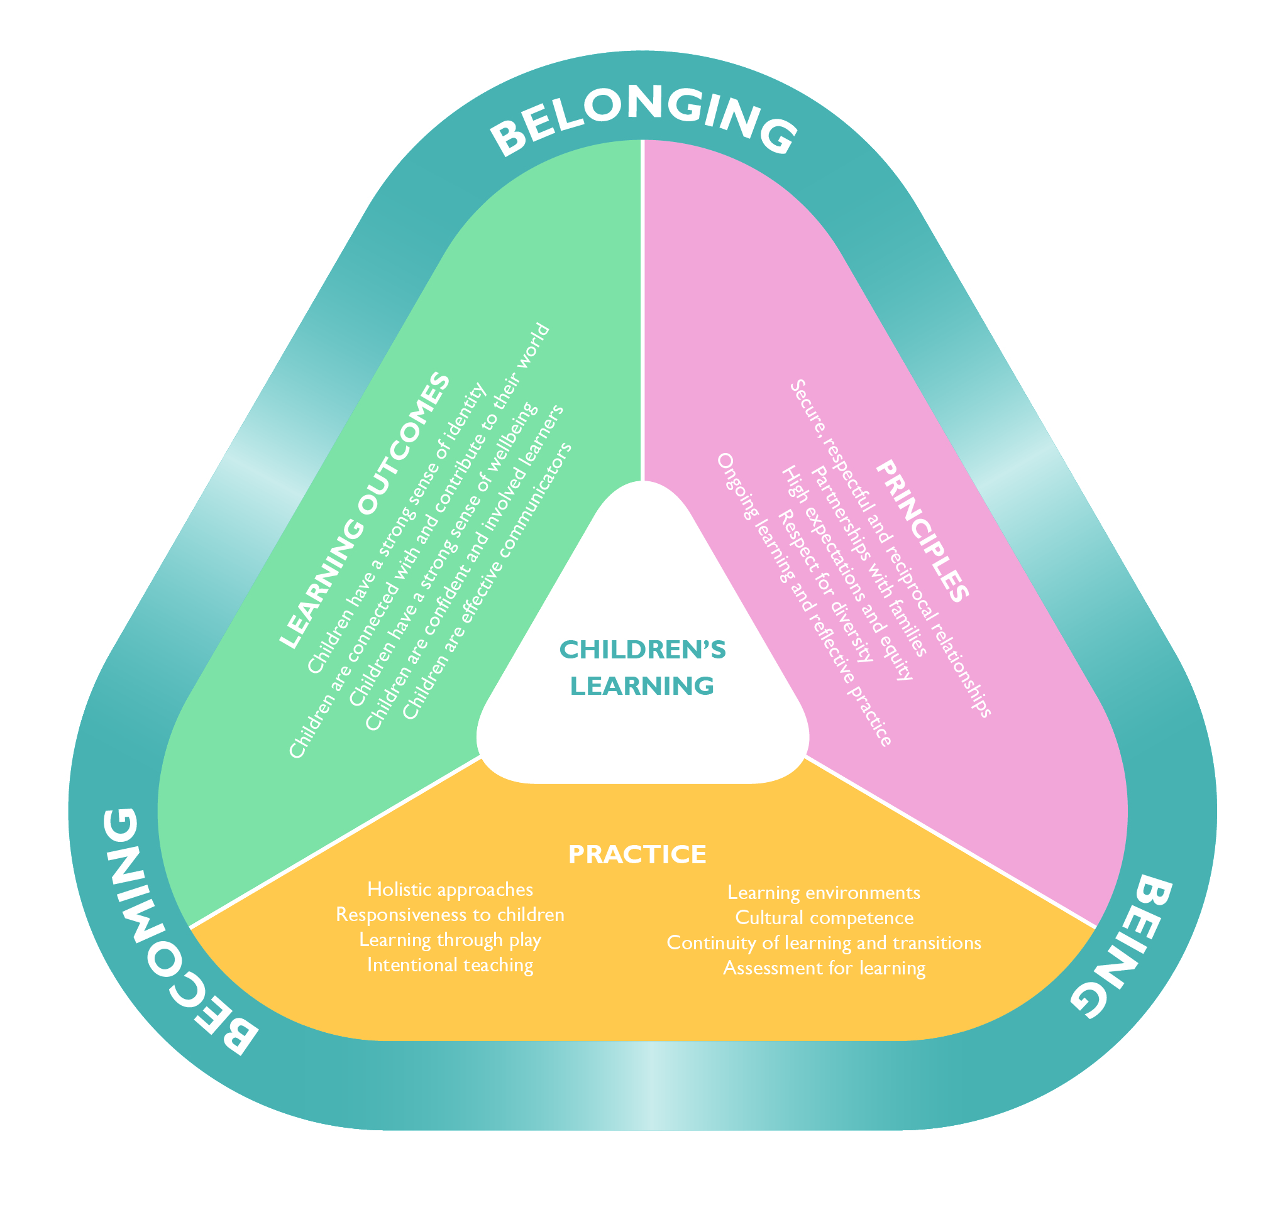
Early Childhood Pedagogy
The term pedagogy refers to the holistic nature of early childhood educators’ professional practice (especially those aspects that involve building and nurturing relationships), curriculum decision-making, teaching and learning. When educators establish respectful and caring relationships with children and families, they are able to work together to construct curriculum and learning experiences relevant to children in their local context. These experiences gradually expand children’s knowledge and understanding of the world.
Educators’ professional judgements are central to their active role in facilitating children’s learning. In making professional judgements, they weave together their:
- professional knowledge and skills
- knowledge of children, families and communities
- awareness of how their beliefs and values impact on children’s learning
- personal styles and past experiences.
They also draw on their creativity, intuition and imagination to help them improvise and adjust their practice to suit the time, place and context of learning.
Different theories about early childhood inform approaches to children’s learning and development. Early childhood educators draw upon a range of perspectives in their work which may include:
- developmental theories that focus on describing and understanding the processes of change in children’s learning and development over time
- socio-cultural theories that emphasise the central role that families and cultural groups play in children’s learning and the importance of respectful relationships and provide insight into social and cultural contexts of learning and development
- socio-behaviourist theories that focus on the role of experiences in shaping children’s behaviour
- critical theories that invite early childhood educators to challenge assumptions about curriculum, and consider how their decisions may affect children differently
- post-structuralist theories that offer insights into issues of power, equity and social justice in early childhood settings.
Drawing on a range of perspectives and theories can challenge traditional ways of seeing children, teaching and learning, and encourage educators, as individuals and with colleagues, to:
- investigate why they act in the ways that they do
- discuss and debate theories to identify strengths and limitations
- recognise how the theories and beliefs that they use to make sense of their work enable but also limit their actions and thoughts
- consider the consequences of their actions for children’s experiences
- find new ways of working fairly and justly.

Principles
The following are five Principles that reflect contemporary theories and research evidence concerning children’s learning and early childhood pedagogy. The Principles underpin practice that is focused on assisting all children to make progress in relation to the Learning Outcomes.
1. Secure, respectful and reciprocal relationships
Educators who are attuned to children’s thoughts and feelings, support the development of a strong sense of wellbeing. They positively interact with the young child in their learning.
Research has shown that babies are both vulnerable and competent. Babies’ first attachments within their families and within other trusting relationships provide them with a secure base for exploration and learning.
Through a widening network of secure relationships, children develop confidence and feel respected and valued. They become increasingly able to recognise and respect the feelings of others and to interact positively with them.
Educators who give priority to nurturing relationships and providing children with consistent emotional support can assist children to develop the skills and understandings they need to interact positively with others. They also help children to learn about their responsibilities to others, to appreciate their connectedness and interdependence as learners, and to value collaboration and teamwork.
2. Partnerships
Learning outcomes are most likely to be achieved when early childhood educators work in partnership with families. Educators recognise that families are children’s first and most influential teachers. They create a welcoming environment where all children and families are respected and actively encouraged to collaborate with educators about curriculum decisions in order to ensure that learning experiences are meaningful.
Partnerships are based on the foundations of understanding each other’s expectations and attitudes, and build on the strength of each others’ knowledge.
In genuine partnerships, families and early childhood educators:
- value each other’s knowledge of each child
- value each other’s contributions to and roles in each child’s life
- trust each other
- communicate freely and respectfully with each other
- share insights and perspectives about each child
- engage in shared decision-making.
Partnerships also involve educators, families and support professionals working together to explore the learning potential in every day events, routines and play so that children with additional needs are provided with daily opportunities to learn from active participation and engagement in these experiences in the home and in early childhood or specialist settings.
3. High expectations and equity
Early childhood educators who are committed to equity believe in all children’s capacities to succeed, regardless of diverse circumstances and abilities. Children progress well when they, their parents and educators hold high expectations for their achievement in learning.
Educators recognise and respond to barriers to children achieving educational success. In response they challenge practices that contribute to inequities and make curriculum decisions that promote inclusion and participation of all children. By developing their professional knowledge and skills, and working in partnership with children, families, communities, other services and agencies, they continually strive to find equitable and effective ways to ensure that all children have opportunities to achieve learning outcomes.
4. Respect for diversity
There are many ways of living, being and of knowing. Children are born belonging to a culture, which is not only influenced by traditional practices, heritage and ancestral knowledge, but also by the experiences, values and beliefs of individual families and communities. Respecting diversity means within the curriculum valuing and reflecting the practices, values and beliefs of families. Educators honour the histories, cultures, languages, traditions, child rearing practices and lifestyle choices of families. They value children’s different capacities and abilities and respect differences in families’ home lives.
Educators recognise that diversity contributes to the richness of our society and provides a valid evidence base about ways of knowing. For Australia it also includes promoting greater understanding of Aboriginal and Torres Strait Islander ways of knowing and being.
When early childhood educators respect the diversity of families and communities, and the aspirations they hold for children, they are able to foster children’s motivation to learn and reinforce their sense of themselves as competent learners. They make curriculum decisions that uphold all children’s rights to have their cultures, identities, abilities and strengths acknowledged and valued,
and respond to the complexity of children’s and families’ lives.
Educators think critically about opportunities and dilemmas that can arise from diversity and take action to redress unfairness. They provide opportunities to learn about similarities and difference and about interdependence and how we can learn to live together.
5. Ongoing learning and reflective practice
Educators continually seek ways to build their professional knowledge and develop learning communities. They become co-learners with children, families and community, and value the continuity and richness of local knowledge shared by community members, including Aboriginal and Torres Strait Islander Elders.
Reflective practice is a form of ongoing learning that involves engaging with questions of philosophy, ethics and practice. Its intention is to gather information and gain insights that support, inform and enrich decision-making about children’s learning. As professionals, early childhood educators examine what happens in their settings and reflect on what they might change.
Critical reflection involves closely examining all aspects of events and experiences from different perspectives. Educators often frame their reflective practice within a set of overarching questions, developing more specific questions for particular areas of enquiry.
Overarching questions to guide reflection include:
- What are my understandings of each child?
- What theories, philosophies and understandings shape and assist my work?
- Who is advantaged when I work in this way? Who is disadvantaged?
- What questions do I have about my work? What am I challenged by? What am I curious about? What am I confronted by?
- What aspects of my work are not helped by the theories and guidance that I usually draw on to make sense of what I do?
- Are there other theories or knowledge that could help me to understand better what I have observed or experienced? What are they? How might those theories and that knowledge affect my practice?
A lively culture of professional inquiry is established when early childhood educators and those with whom they work are all involved in an ongoing cycle of review through which current practices are examined, outcomes reviewed and new ideas generated. In such a climate, issues relating to curriculum quality, equity and children’s wellbeing can be raised and debated.

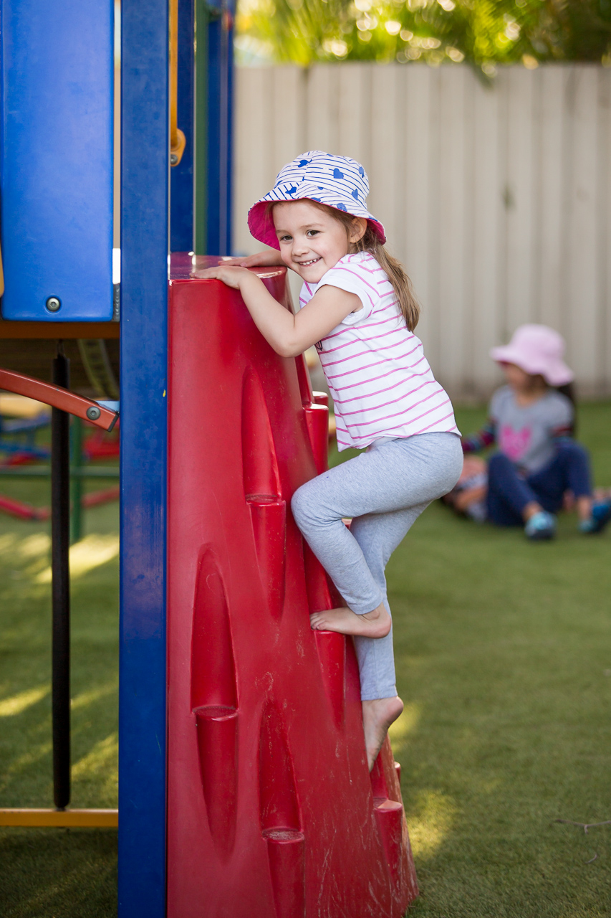
Practice

The principles of early childhood pedagogy underpin practice. Educators draw on a rich repertoire of pedagogical practices to promote children’s learning by:
- adopting holistic approaches
- being responsive to children
- planning and implementing learning through play
- intentional teaching
- creating physical and social learning environments that have a positive impact on children’s learning
- valuing the cultural and social contexts of children and their families
- providing for continuity in experiences and enabling children to have successful transition
- assessing and monitoring children’s learning to inform provision and to support children in achieving learning outcomes.

Holistic approaches
Holistic approaches to teaching and learning recognise the connectedness of mind, body and spirit⁴. When early childhood educators take a holistic approach they pay attention to children’s physical, personal, social, emotional and spiritual wellbeing as well as cognitive aspects of learning. While educators may plan or assess with a focus on a particular outcome or component of learning, they see children’s learning as integrated and interconnected. They recognise the connections between children, families and communities and the importance of reciprocal relationships and partnerships for learning. They see learning as a social activity and value collaborative learning and community participation.
An integrated, holistic approach to teaching and learning also focuses on connections to the natural world. Educators foster children’s capacity to understand and respect the natural environment and the interdependence between people, plants, animals and the land.

Responsiveness to children
Educators are responsive to all children’s strengths, abilities and interests. They value and build on children’s strengths, skills and knowledge to ensure their motivation and engagement in learning. They respond to children’s expertise, cultural traditions and ways of knowing, the multiple languages spoken by some children, particularly Aboriginal and Torres Strait Islander children, and the strategies used by children with additional needs to negotiate their every day lives.

4 Siraj-Blatchford, I., & Sylva, K. (2004). Researching pedagogy in English pre-schools. British Educational Research Journal, 30(5), 712-730.
Educators are also responsive to children’s ideas and play, which form an important basis for curriculum decision-making. In response to children’s evolving ideas and interests, educators assess, anticipate and extend children’s learning via open ended questioning, providing feedback, challenging their thinking and guiding their learning. They make use of spontaneous ‘teachable moments’ to scaffold children’s learning.
Responsive learning relationships are strengthened as educators and children learn together and share decisions, respect and trust. Responsiveness enables educators to respectfully enter children’s play and ongoing projects, stimulate their thinking and enrich their learning.
Examples of how educators can reflect on their practice can be found in the description of the Learning Outcomes.

Scaffold:
the educators’ decisions and actions that build on children’s existing knowledge and skills to enhance their learning.

Learning through play
Play provides opportunities for children to learn as they discover, create, improvise and imagine. When children play with other children they create social groups, test out ideas, challenge each other’s thinking and build new understandings. Play provides a supportive environment where children can ask questions, solve problems and engage in critical thinking. Play can expand children’s thinking and enhance their desire to know and to learn. In these ways play can promote positive dispositions towards learning. Children’s immersion in their play illustrates how play enables them to simply enjoy being.
Early childhood educators take on many roles in play with children and use a range of strategies to support learning. They engage in sustained shared conversations with children to extend their thinking⁵.They provide a balance between child led, child initiated and educator supported learning. They create learning environments that encourage children to explore, solve problems, create and construct. Educators interact with babies and children to build attachment. They use routines and play experiences to do this. They also recognise spontaneous teachable moments as they occur, and use them to build on children’s learning. Early childhood educators work with young children to promote and model positive ways to relate to others. They actively support the inclusion of all children in play, help children to recognise when play is unfair and offer constructive ways to build a caring, fair and inclusive learning community.

Intentional teaching: involves educators being deliberate, purposeful and thoughtful in their decisions and action. Intentional teaching is the opposite of teaching by rote or continuing with traditions simply because things have ‘always’ been done that way.

5 Sraj-Blatchford, I., & Sylva, K. (2004). Researching pedagogy in English pre-schools. British Educational Research Journal, 30(5), 712-730.

Intentional teaching
Intentional teaching is deliberate, purposeful and thoughtful.
Educators who engage in intentional teaching recognise that learning occurs in social contexts and that interactions and conversations are vitally important for learning. They actively promote children’s learning through worthwhile and challenging experiences and interactions that foster high-level thinking skills. They use strategies such as modelling and demonstrating, open questioning, speculating, explaining, engaging in shared thinking and problem solving to extend children’s thinking and learning. Educators move flexibly in and out of different roles and draw on different strategies as the context changes. They plan opportunities for intentional teaching and knowledge-building. They document and monitor children’s learning.

Learning environments
Learning environments are welcoming spaces when they reflect and enrich the lives and identities of children and families participating in the setting and respond to their interests and needs. Environments that support learning are vibrant and flexible spaces that are responsive to the interests and abilities of each child. They cater for different learning capacities and learning styles and invite children and families to contribute ideas, interests and questions.
Outdoor learning spaces are a feature of Australian learning environments. They offer a vast array of possibilities not available indoors. Play spaces in natural environments include plants, trees, edible gardens, sand, rocks, mud, water and other elements from nature. These spaces invite open-ended interactions, spontaneity, risk-taking, exploration, discovery and connection with nature. They foster an appreciation of the natural environment, develop environmental awareness and provide a platform
for ongoing environmental education.
Indoor and outdoor environments support all aspects of children’s learning and invite conversations between children, early childhood educators, families and the broader community. They promote opportunities for sustained shared thinking and collaborative learning.
Materials enhance learning when they reflect what is natural and familiar and also introduce novelty to provoke interest and more complex and increasingly abstract thinking. For example, digital technologies can enable children to access global connections and resources, and encourage new ways of thinking. Environments and resources can also highlight our responsibilities for a sustainable future and promote children’s understanding about their responsibility to care for the environment. They can foster hope, wonder and knowledge about the natural world.
Educators can encourage children and families to contribute ideas, interests and questions to the learning environment. They can support engagement by allowing time for meaningful interactions, by providing a range of opportunities for individual and shared experiences, and by finding opportunities for children to go into and contribute to their local community.

Cultural competence
Educators who are culturally competent respect multiple cultural ways of knowing, seeing and living, celebrate the benefits of diversity and have an ability to understand and honour differences. This is evident in everyday practice when educators demonstrate an ongoing commitment to developing their own cultural competence in a two way process with families and communities.
Educators view culture and the context of family as central to children’s sense of being and belonging, and to success in lifelong learning. Educators also seek to promote children’s cultural competence.
Cultural competence is much more than awareness of cultural differences. It is the ability to understand, communicate with, and effectively interact with people across cultures. Cultural competence encompasses:
- being aware of one’s own world view
- developing positive attitudes towards cultural differences
- gaining knowledge of different cultural practices and world views
- developing skills for communication and interaction across cultures.

Continuity of learning and transitions
Children bring family and community ways of being, belonging and becoming to their early childhood settings. By building on these experiences educators help all children to feel secure, confident and included and to experience continuity in how to be and how to learn.
Transitions, including from home to early childhood settings, between settings, and from early childhood settings to school, offer opportunities and challenges. Different places and spaces have their own purposes, expectations and ways of doing things. Building on children’s prior and current experiences helps them to feel secure, confident and connected to familiar people, places, events and understandings. Children, families and early childhood educators all contribute to successful transitions between settings.
In partnership with families, early childhood educators ensure that children have an active role in preparing for transitions. They assist children to understand the traditions, routines and practices of the settings to which they are moving and to feel comfortable with the process of change.
Early childhood educators also help children to negotiate changes in their status or identities, especially when they begin full-time school. As children make transitions to new settings (including school) educators from early childhood settings and schools commit to sharing information about each child’s knowledge and skills so learning can build on foundations of earlier learning. Educators work collaboratively with each child’s new educator and other professionals to ensure a successful transition.

Assessment for learning
Assessment for children’s learning refers to the process of gathering and analysing information as evidence about what children know, can do and understand. It is part of an ongoing cycle that includes planning, documenting and evaluating children’s learning.
It is important because it enables educators in partnership with families, children and other professionals to:
- plan effectively for children’s current and future learning
- communicate about children’s learning and progress
- determine the extent to which all children are progressing toward realising learning outcomes and if not, what might be impeding their progress
- identify children who may need additional support in order to achieve particular learning outcomes, providing that support or assisting families to access specialist help
- evaluate the effectiveness of learning opportunities, environments and experiences offered and the approaches taken to enable children’s learning
- reflect on pedagogy that will suit this context and these children.

Educators use a variety of strategies to collect, document, organise, synthesise and interpret the information that they gather to assess children’s learning. They search for appropriate ways to collect rich and meaningful information that depicts children’s learning in context, describes their progress and identifies their strengths, skills and understandings. More recent approaches to assessment also examine the learning strategies that children use and reflect ways in which learning is co-constructed through interactions between the educator and each child. Used effectively, these approaches to assessment become powerful ways to make the process of learning visible to children and their families, educators and other professionals.
The five Learning Outcomes in this Framework, as outlined later, provide early childhood educators with key reference points against which children’s progress can be identified, documented and communicated to families, other early childhood professionals and educators in schools. Over time educators can reflect on how children have developed, how they have engaged with increasingly complex ideas and participated in increasingly sophisticated learning experiences.
Ongoing assessment processes that include a diverse array of methods capture and validate the different pathways that children take toward achieving these outcomes. Such processes do not focus exclusively on the endpoints of children’s learning; they give equal consideration to the ‘distance-travelled’ by individual children and recognise and celebrate not only the giant leaps that children take in their learning but the small steps as well.
All children demonstrate their learning in different ways. Approaches to assessment that are culturally and linguistically relevant and responsive to the physical and intellectual capabilities of each child will acknowledge each child’s abilities and strengths, and allow them to demonstrate competence.
Including children, families and other professionals in the development and implementation of relevant and appropriate assessment processes allows for new understandings to emerge that are not possible if educators rely solely on their own strategies and perspectives. Developing inclusive assessment practices with children and their families demonstrates respect for diversity, helps educators make better sense of what they have observed and supports learning for both children and adults.
Assessment, when undertaken in collaboration with families, can assist families to support children’s learning and empower them to act on behalf of their children beyond the early childhood setting. When children are included in the assessment process they can develop an understanding of themselves as learners and an understanding of how they learn best.
When educators reflect on their role in children’s learning and assessment they reflect on their own views and understandings of early childhood theory, research and practice to focus on:
- the experiences and environments they provide and how that links to the intended learning outcomes
- the extent to which they know and value the culturally specific knowledge about children and learning that is embedded within the community in which they are working
- each child’s learning in the context of their families, drawing family perspectives, understandings, experiences and expectations
- the learning opportunities which build on what children already know and what they bring to the early childhood setting
- evidence that the learning experiences offered are inclusive of all children and culturally appropriate
- not making assumptions about children’s learning or setting lower expectations for some children because of unacknowledged biases
- incorporating pedagogical practices that reflect knowledge of diverse perspectives and contribute to children’s wellbeing and successful learning
- whether there are sufficiently challenging experiences for all children
- the evidence that demonstrates children are learning
- how they can expand the range of ways they assess to make assessment richer and more useful.

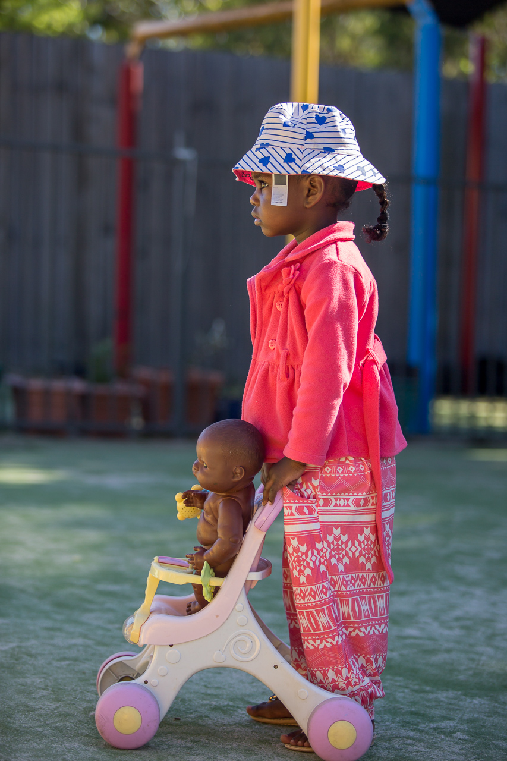

LEARNING OUTCOMES
The five Learning Outcomes are designed to capture the integrated and complex learning and development of all children across the birth to five age range. The outcomes are:
- Children have a strong sense of identity
- Children are connected with and contribute
to their world
- Children have a strong sense of wellbeing
- Children are confident and involved learners
- Children are effective communicators.
The outcomes are broad and observable. They acknowledge that children learn in a variety of ways and vary in their capabilities and pace of learning. Over time children engage with increasingly complex ideas and learning experiences, which are transferable to other situations.
Learning in relation to the outcomes is influenced by:
- each child’s current capabilities, dispositions and learning preferences
- educators’ practices and the early childhood environment
- engagement with each child’s family and community
- the integration of learning across the outcomes.
Children’s learning is ongoing and each child will progress towards the outcomes in different and equally meaningful ways. Learning is not always predictable and linear. Educators plan with each child and the outcomes in mind.
The following Learning Outcomes demonstrate how the three elements of the Framework: Principles, Practices and Outcomes combine to guide curriculum decision-making and assessment to promote children’s learning.
Key components of learning in each outcome are expanded to provide examples of evidence that educators may observe in children as they learn. Examples of practice to promote children’s learning are also included.
There will be many other ways that children demonstrate learning within and across the outcomes. Educators understand, engage with and promote children’s learning. They talk with families and communities to make locally based decisions, relevant to each child and their community.
There is provision for educators to list specific examples of evidence and practice that are culturally and contextually appropriate to each child and their settings.
The points described within each outcome are relevant to children of all ages. Knowledge of individual children, their strengths and capabilities will guide educators’ professional judgement to ensure all children are engaging in a range of experiences across all the Learning Outcomes
in ways that optimise their learning.

Outcome 1:
Children have a strong sense of identity
Belonging, being and becoming are integral parts of identity.
Children learn about themselves and construct their own identity within the context of their families and communities. This includes their relationships with people, places and things and the actions and responses of others. Identity is not fixed. It is shaped by experiences. When children have positive experiences they develop an understanding of themselves as significant and respected, and feel a sense of belonging. Relationships are the foundations for the construction of identity – ‘who I am’, ‘how I belong’ and ‘what is my influence?’
In early childhood settings children develop a sense of belonging when they feel accepted, develop attachments and trust those that care for them. As children are developing their sense of identity, they explore different aspects of it (physical, social, emotional, spiritual, cognitive), through their play and their relationships.
When children feel safe, secure and supported they grow in confidence to explore and learn.
The concept of being reminds educators to focus on children in the here and now, and of the importance of children’s right to be a child and experience the joy of childhood. Being involves children developing an awareness of their social and cultural heritage, of gender and their significance in their world.
Becoming includes children building and shaping their identity through their evolving experiences and relationships which include change and transitions. Children are always learning about the impact of their personal beliefs and values. Children’s agency, as well as guidance, care and teaching by families and educators shape children’s experiences of becoming.
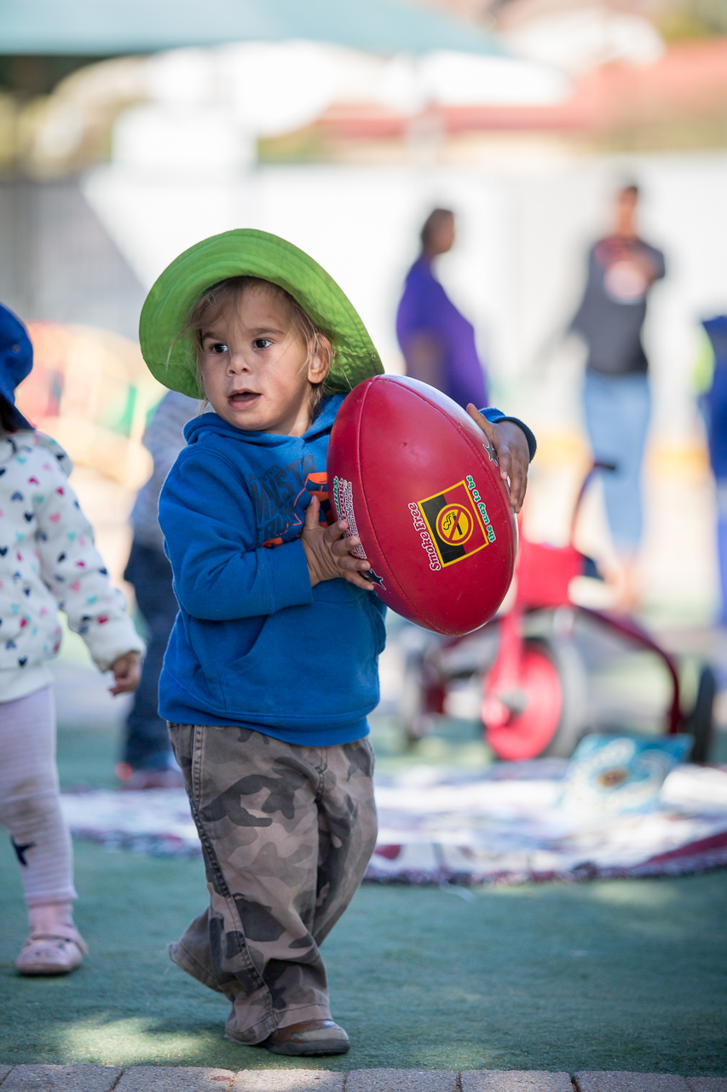

Outcome 1: Children have a strong sense of identity
- Children feel safe, secure, and supported
- Children develop their emerging autonomy, inter-dependence, resilience and sense of agency
- Children develop knowledgeable and confident self identities
- Children learn to interact in relation to others with care, empathy and respect

Children feel safe, secure, and supported
This is evident, for example, when children:  - build secure attachments with one and then more familiar educators  - use effective routines to help make predicted transitions smoothly  - sense and respond to a feeling of belonging  - communicate their needs for comfort and assistance  - establish and maintain respectful, trusting relationships with other children and educators  - openly express their feelings and ideas in their interactions with others  - respond to ideas and suggestions from others  - initiate interactions and conversations with trusted educators  - confidently explore and engage with social and physical environments through relationships and play  - initiate and join in play  - explore aspects of identity through role play | Educators promote this learning, for example, when they:  - acknowledge and respond sensitively  to children’s cues and signals  - respond sensitively to children’s attempts  to initiate interactions and conversations  - support children’s secure attachment through consistent and warm nurturing relationships  - support children in times of change and bridge the gap between the familiar and the unfamiliar  - build upon culturally valued child rearing practices and approaches to learning  - are emotionally available and support children’s expression of their thoughts  and feelings  - recognise that feelings of distress, fear or discomfort may take some time to resolve  - acknowledge each child’s uniqueness in positive ways  - spend time interacting and conversing with each child
Add your own examples from your context:

Outcome 1: Children have a strong sense of identity

Children develop their emerging autonomy, inter-dependence, resilience and sense of agency
This is evident, for example, when children:  - demonstrate increasing awareness of the needs and rights of others  - be open to new challenges and discoveries  - increasingly co-operate and work collaboratively with others  - take considered risk in their decision-making and cope with the unexpected  - recognise their individual achievements and the achievements of others  - demonstrate an increasing capacity for  self-regulation  - approach new safe situations with confidence  - begin to initiate negotiating and sharing behaviours  - persist when faced with challenges and when first attempts are not successful | Educators promote this learning, for example, when they:  - provide children with strategies to make informed choices about their behaviours  - promote children’s sense of belonging, connectedness and wellbeing  - maintain high expectations of each child’s capabilities  - mediate and assist children to negotiate their rights in relation to the rights of others  - provide opportunities for children to engage independently with tasks and play  - display delight, encouragement and enthusiasm for children’s attempts  - support children’s efforts, assisting and encouraging as appropriate  - motivate and encourage children to succeed when they are faced with challenges  - provide time and space for children to engage in both individual and collaborative pursuits  - build on the culturally valued learning of individual children’s communities  - encourage children to make choices and decisions
Add your own examples from your context:

Outcome 1: Children have a strong sense of identity

Children develop knowledgeable and confident self identities
This is evident, for example, when children:  - feel recognised and respected for who  they are  - explore different identities and points of view in dramatic play  - share aspects of their culture with the other children and educators  - use their home language to construct meaning  - develop strong foundations in both the culture and language/s of their family and of the broader community without compromising their cultural identities  - develop their social and cultural heritage through engagement with Elders and community members  - reach out and communicate for comfort, assistance and companionship  - celebrate and share their contributions and achievements with others | Educators promote this learning, for example, when they:  - promote in all children a strong sense of who they are and their connectedness to others – a shared identity as Australians  - ensure all children experience pride and confidence in their achievements  - share children’s successes with families  - show respect for diversity, acknowledging the varying approaches of children, families, communities and cultures  - acknowledge and understand that children construct meaning in many different ways  - demonstrate deep understanding of each child, their family and community contexts in planning for children’s learning  - provide children with examples of the many ways identities and culture are recognised and expressed  - build upon culturally valued approaches to learning  - build on the knowledge, languages and understandings that children bring  - talk with children in respectful ways about similarities and differences in people  - provide rich and diverse resources that reflect children’s social worlds  - listen to and learn about children’s understandings of themselves  - actively support the maintenance of home language and culture  - develop authentic children’s understanding of themselves
Add your own examples from your context:

Outcome 1: Children have a strong sense of identity

Children learn to interact in relation to others with care, empathy and respect
This is evident, for example, when children:  - show interest in other children and being part of a group  - engage in and contribute to shared play experiences  - express a wide range of emotions, thoughts and views constructively  - empathise with and express concern for others  - display awareness of and respect for others’ perspectives  - reflect on their actions and consider consequences for others | Educators promote this learning, for example, when they:  - initiate one-to-one interactions with children, particularly babies and toddlers, during daily routines  - organise learning environments in ways that promote small group interactions and play experiences  - model care, empathy and respect for children, staff and families  - model explicit communication strategies to support children to initiate interactions and join in play and social experiences in ways that sustain productive relationships with other children  - acknowledge children’s complex relationships and sensitively intervene in ways that promote consideration of alternative perspectives and social inclusion
Add your own examples from your context:

Inclusion:
involves taking into account all children’s social, cultural and linguistic diversity (including learning styles, abilities, disabilities, gender, family circumstances and geographic location) in curriculum decision-making processes. The intent is to ensure that all children’s experiences are recognised and valued. The intent is also to ensure that all children have equitable access to resources and participation, and opportunities to demonstrate their learning and to value difference.

Outcome 2: Children are connected with and contribute to their world
Experiences of relationships and participation in communities contribute to children’s belonging, being and becoming. From birth children experience living and learning with others in a range of communities. These might include families, local communities or early childhood settings. Having a positive sense of identity and experiencing respectful, responsive relationships strengthens children’s interest and skills in being and becoming active contributors to their world. As children move into early childhood settings they broaden their experiences as participants in different relationships and communities.
Over time the variety and complexity of ways in which children connect and participate with others increases. Babies participate through smiling, crying, imitating, and making sounds to show their level of interest in relating to or participating with others. Toddlers participate and connect with other toddlers through such gestures as offering their teddy to a distressed child or welcoming a new child enthusiastically. Older children show interest in how others regard them and understandings about friendships. They develop understandings that their actions or responses affect how others feel or experience belonging.
When educators create environments in which children experience mutually enjoyable, caring and respectful relationships with people and the environment, children respond accordingly. When children participate collaboratively in everyday routines, events and experiences and have opportunities to contribute to decisions, they learn to live interdependently.
Children’s connectedness and different ways of belonging with people, country and communities helps them to learn ways of being which reflect the values, traditions and practices of their families and communities. Over time this learning transforms the ways they interact with others.

Outcome 2: Children are connected with and contribute to their world
- Children develop a sense of belonging to groups and communities and an understanding of the
reciprocal rights and responsibilities necessary for active community participation
- Children respond to diversity with respect
- Children become aware of fairness
- Children become socially responsible and show respect for the environment

Children develop a sense of belonging to groups and communities and an understanding of the reciprocal rights and responsibilities necessary for active community participation
This is evident, for example, when children:  - begin to recognise that they have a right to belong to many communities  - cooperate with others and negotiate roles and relationships in play episodes and group experiences  - take action to assist other children to participate in social groups  - broaden their understanding of the world  in which they live  - express an opinion in matters that affect them  - build on their own social experiences to explore other ways of being  - participate in reciprocal relationships  - gradually learn to ‘read’ the behaviours of others and respond appropriately  - understand different ways of contributing through play and projects  - demonstrate a sense of belonging and comfort in their environments  - are playful and respond positively to others, reaching out for company and friendship  - contribute to fair decision-making about matters that affect them | Educators promote this learning, for example, when they:  - promote a sense of community within the early childhood setting  - build connections between the early childhood setting and the local community  - provide opportunities for children to investigate ideas, complex concepts and ethical issues that are relevant to their lives and their local communities  - model language that children can use to express ideas, negotiate roles and collaborate to achieve goals  - ensure that children have the skills to participate and contribute to group play and projects  - plan opportunities for children to participate in meaningful ways in group discussions and shared decision-making about rules and expectations
Add your own examples from your context:

Outcome 2: Children are connected with and contribute to their world

Children respond to diversity with respect
This is evident, for example, when children:  - begin to show concern for others  - explore the diversity of culture, heritage, background and tradition and that diversity presents opportunities for choices and new understandings  - become aware of connections, similarities and differences between people  - listen to others’ ideas and respect different ways of being and doing  - practise inclusive ways of achieving coexistence  - notice and react in positive ways to similarities and differences among people | Educators promote this learning, for example, when they:  - reflect on their own responses to diversity  - plan experiences and provide resources that broaden children’s perspectives and encourage appreciation of diversity  - expose children to different languages and dialects and encourage appreciation of linguistic diversity  - encourage children to listen to others and to respect diverse perspectives  - demonstrate positive responses to diversity in their own behaviour and in conversations with children  - engage in interactions with children that promote respect for diversity and value distinctiveness  - explore the culture, heritage, backgrounds and traditions of each child within the context of their community  - explore with children their ideas about diversity
Add your own examples from your context:

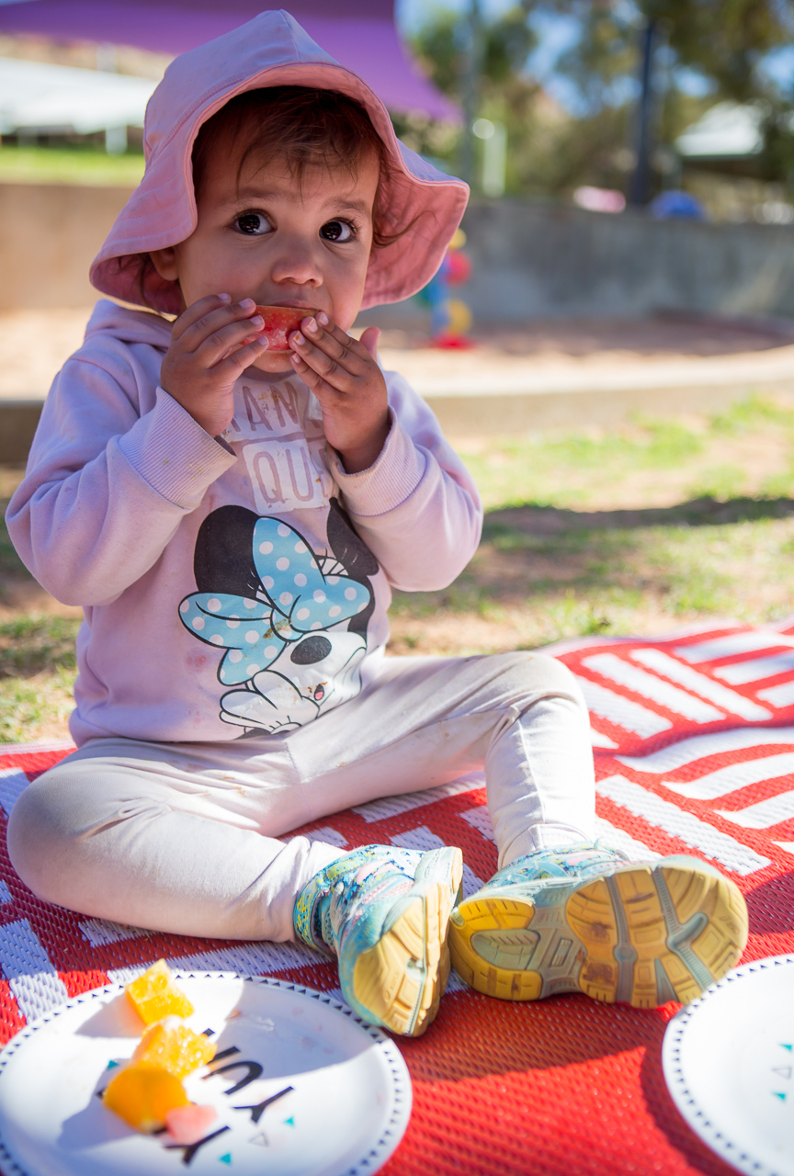
Outcome 2: Children are connected with and contribute to their world

Children become aware of fairness
This is evident, for example, when children:  - discover and explore some connections amongst people  - become aware of ways in which people are included or excluded from physical and social environments  - develop the ability to recognise unfairness and bias and the capacity to act with compassion and kindness  - are empowered to make choices and problem solve to meet their needs in particular contexts  - begin to think critically about fair and unfair behaviour  - begin to understand and evaluate ways in which texts construct identities and create stereotypes | Educators promote this learning, for example, when they:  - notice and listen carefully to children’s concerns and discuss diverse perspectives on issues of inclusion and exclusion and fair and unfair behaviour  - engage children in discussions about respectful and equal relations such as when a child dominates in the use of resources  - analyse and discuss with children ways in which texts construct a limited range of identities and reinforce stereotypes  - draw children’s attention to issues of fairness relevant to them in the early childhood setting and community
Add your own examples from your context:

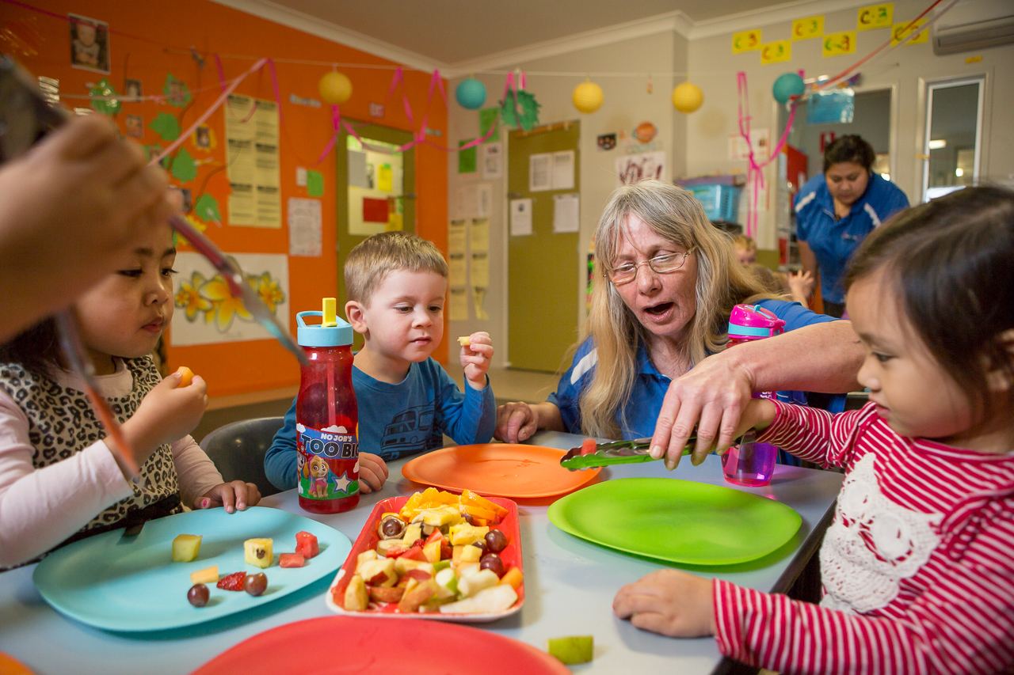
Outcome 2: Children are connected with and contribute to their world

Children become socially responsible and show respect for the environment
This is evident, for example, when children:  - use play to investigate, project and explore new ideas  - participate with others to solve problems and contribute to group outcomes  - demonstrate an increasing knowledge of, and respect for natural and constructed environments  - explore, infer, predict and hypothesise in order to develop an increased understanding of the interdependence between land, people, plants and animals  - show growing appreciation and care for natural and constructed environments  - explore relationships with other living and non-living things and observe, notice and respond to change  - develop an awareness of the impact of human activity on environments and the interdependence of living things | Educators promote this learning, for example, when they:  - provide children with access to a range of natural materials in their environment  - model respect, care and appreciation for the natural environment  - find ways of enabling children to care for and learn from the land  - consider the nature of children’s connectedness to the land and demonstrate respect for community protocols  - share information and provide children with access to resources about the environment and the impact of human activities on environments  - embed sustainability in daily routines and practices  - look for examples of interdependence in the environment and discuss the ways the life and health of living things are interconnected
Add your own examples from your context:

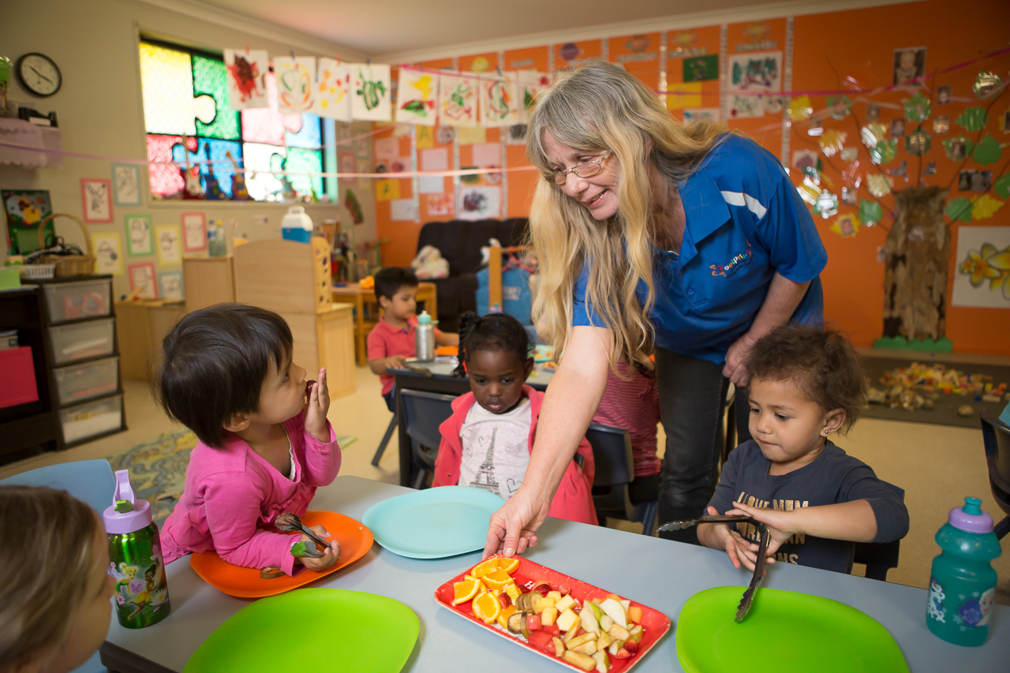
Outcome 3:
Children have a strong sense of wellbeing
Wellbeing incorporates both physical and psychological aspects and is central to belonging, being and becoming. Without a strong sense of wellbeing it is difficult to have a sense of belonging, to trust others and feel confident in being, and to optimistically engage in experiences that contribute to becoming.
Wellbeing includes good physical health, feelings of happiness, satisfaction and successful social functioning. It influences the way children interact in their environments. A strong sense of wellbeing provides children with confidence and optimism which maximise their learning potential. It encourages the development of children’s innate exploratory drive, a sense of agency and a desire to interact with responsive others.
Wellbeing is correlated with resilience, providing children with the capacity to cope with day-to day stress and challenges. The readiness to persevere when faced with unfamiliar and challenging learning situations creates the opportunity for success and achievement.
Children’s learning and physical development is evident through their movement patterns from physical dependence and reflex actions at birth, to the integration of sensory, motor and cognitive systems for organised, controlled physical activity for both purpose and enjoyment.
Children’s wellbeing can be affected by all their experiences within and outside of their early childhood settings. To support children’s learning, it is essential that educators attend to children’s wellbeing by providing warm, trusting relationships, predictable and safe environments, affirmation and respect for all aspects of their physical, emotional, social, cognitive, linguistic, creative and spiritual being. By acknowledging each child’s cultural and social identity, and responding sensitively to their emotional states, educators build children’s confidence, sense of wellbeing and willingness to engage in learning.
Children’s developing resilience and their ability to take increasing responsibility for self-help and basic health routines promote a sense of independence and confidence. As they experience being cared for by educators and others, they become aware of the importance of living and learning interdependently with others.
Learning about healthy lifestyles, including nutrition, personal hygiene, physical fitness, emotions and social relationships is integral to wellbeing and self-confidence. Physical wellbeing contributes to children’s ability to concentrate, cooperate and learn. As children become more independent they can take greater responsibility for their health, hygiene and personal care and become mindful of their own and others’ safety. Routines provide opportunities for children to learn about health and safety. Good nutrition is essential to healthy living and enables children to be active participants in play. Early childhood settings provide many opportunities for children to experience a range of healthy foods and to learn about food choices from educators and other children. Physical activity and attention to fine and gross motor skills provide children with the foundations for their growing independence and satisfaction in being able to do things for themselves.

Outcome 3: Children have a strong sense of wellbeing
- Children become strong in their social and emotional wellbeing
- Children take increasing responsibility for their own health and physical wellbeing

Children become strong in their social and emotional wellbeing
This is evident, for example, when children:  - demonstrate trust and confidence  - remain accessible to others at times of distress, confusion and frustration  - share humour, happiness and satisfaction  - seek out and accept new challenges, make new discoveries, and celebrate their own efforts and achievements and those of others  - increasingly co-operate and work collaboratively with others  - enjoy moments of solitude  - recognise their individual achievement  - make choices, accept challenges, take considered risks, manage change and cope with frustrations and the unexpected  - show an increasing capacity to understand, self-regulate and manage their emotions in ways that reflect the feelings and needs of others  - experience and share personal successes in learning and initiate opportunities for new learning in their home languages or Standard Australian English  - acknowledge and accept affirmation  - assert their capabilities and independence while demonstrating increasing awareness of the needs and rights of others  - recognise the contributions they make to shared projects and experiences | Educators promote this learning, for example, when they:  - show genuine affection, understanding  and respect for all children  - collaborate with children to document their achievements and share their successes with their families  - ensure that all children experience pride in their attempts and achievements  - promote children’s sense of belonging, connectedness and wellbeing  - challenge and support children to engage in and persevere at tasks and play  - build upon and extend children’s ideas  - maintain high expectations of each child’s capabilities  - value children’s personal decision-making  - welcome children and families sharing aspects of their culture and spiritual lives  - talk with children about their emotions and responses to events with a view to supporting their understandings of emotional regulation and self-control  - acknowledge and affirm children’s effort  and growth  - mediate and assist children to negotiate their rights in relation to the rights of others
Add your own examples from your context:

Outcome 3: Children have a strong sense of wellbeing

Children take increasing responsibility for their own health and physical wellbeing
This is evident, for example, when children:  - recognise and communicate their bodily needs (for example, thirst, hunger, rest, comfort, physical activity)  - are happy, healthy, safe and connected  to others  - engage in increasingly complex sensory-motor skills and movement patterns  - combine gross and fine motor movement and balance to achieve increasingly complex patterns of activity including dance, creative movement and drama  - use their sensory capabilities and dispositions with increasing integration,  skill and purpose to explore and respond  to their world  - demonstrate spatial awareness and orient themselves, moving around and through their environments confidently and safely  - manipulate equipment and manage tools with increasing competence and skill  - respond through movement to traditional and contemporary music, dance and storytelling  - show an increasing awareness of healthy lifestyles and good nutrition  - show increasing independence and competence in personal hygiene, care and safety for themselves and others  - show enthusiasm for participating in physical play and negotiate play spaces to ensure the safety and wellbeing of themselves and others | Educators promote this learning, for example, when they:  - plan for and participate in energetic physical activity with children, including dance, drama, movement and games  - draw on family and community experiences and expertise to include familiar games and physical activities in play  - provide a wide range of tools and  materials to resource children’s fine and gross motor skills  - actively support children to learn hygiene practices  - promote continuity of children’s personal health and hygiene by sharing ownership of routines and schedules with children, families and the community  - discuss health and safety issues with children and involve them in developing guidelines to keep the environment safe for all  - engage children in experiences, conversations and routines that promote healthy lifestyles and good nutrition  - consider the pace of the day within the context of the community  - model and reinforce health, nutrition and personal hygiene practices with children  - provide a range of active and restful experiences throughout the day and support children to make appropriate decisions regarding participation
Add your own examples from your context:

Outcome 4: Children are confident and involved learners
A sense of security and sound wellbeing gives children the confidence to experiment and explore and to try out new ideas, thus developing their competence and becoming active and involved participants in learning. Children are more likely to be confident and involved learners when their family and community experiences and understandings are recognised and included in the early childhood setting. This assists them to make connections and to make sense of new experiences.
Children use processes such as exploration, collaboration and problem solving across all aspects of curriculum. Developing dispositions such as curiosity, persistence and creativity enables children to participate in and gain from learning. Effective learners are also able to transfer and adapt what they have learned from one context to another and to locate and use resources for learning.
In a supportive active learning environment, children who are confident and involved learners are increasingly able to take responsibility for their own learning, personal regulation and contribution to the social environment. Connections and continuity between learning experiences in different settings make learning more meaningful and increase children’s feelings of belonging.
Children develop understandings of themselves and their world through active, hands-on investigation. A supportive active learning environment encourages children’s engagement in learning which can be recognised as deep concentration and complete focus on what captures their interests. Children bring their being to their learning. They have many ways of seeing the world, different processes of learning and their own preferred learning styles.
Active involvement in learning builds children’s understandings of concepts and the creative thinking and inquiry processes that are necessary for lifelong learning. They can challenge and extend their own thinking, and that of others, and create new knowledge in collaborative interactions and negotiations. Children’s active involvement changes what they know, can do, value and transforms their learning.
Educators’ knowledge of individual children is crucial to providing an environment and experiences that will optimise children’s learning.

Outcome 4: Children are confident and involved learners
- Children develop dispositions for learning such as curiosity, cooperation, confidence, creativity, commitment, enthusiasm, persistence, imagination and reflexivity
- Children develop a range of skills and processes such as problem solving, enquiry, experimentation, hypothesising, researching and investigating
- Children transfer and adapt what they have learned from one context to another
- Children resource their own learning through connecting with people, place, technologies and natural and processed materials

Children develop dispositions for learning such as curiosity, cooperation, confidence, creativity, commitment, enthusiasm, persistence, imagination and reflexivity
This is evident, for example, when children:  - express wonder and interest in their environments  - are curious and enthusiastic participants in their learning  - use play to investigate, imagine and explore ideas  - follow and extend their own interests with enthusiasm, energy and concentration  - initiate and contribute to play experiences emerging from their own ideas  - participate in a variety of rich and meaningful inquiry-based experiences  - persevere and experience the satisfaction of achievement  - persist even when they find a task difficult | Educators promote this learning, for example, when they:  - recognise and value children’s involvement in learning  - provide learning environments that are flexible and open-ended  - respond to children’s displays of learning dispositions by commenting on them and providing encouragement and additional ideas  - encourage children to engage in both individual and collaborative explorative learning processes  - listen carefully to children’s ideas and discuss with them how these ideas might  be developed  - provide opportunities for children to revisit their ideas and extend their thinking  - model inquiry processes, including wonder, curiosity and imagination, try new ideas and take on challenges  - reflect with children on what and how they have learned  - build on the knowledge, languages and understandings that children bring to their early childhood setting  - explore the diversity of cultures and social identities  - promote in children a strong sense of who they are and their connectedness to others – a shared identity as Australians
Add your own examples from your context:

Outcome 4: Children are confident and involved learners

Children develop a range of skills and processes such as problem solving, inquiry, experimentation, hypothesising, researching and investigating
This is evident, for example, when children:  - apply a wide variety of thinking strategies to engage with situations and solve problems, and adapt these strategies to new situations  - create and use representation to organise, record and communicate mathematical ideas and concepts  - make predictions and generalisations about their daily activities, aspects of the natural world and environments, using patterns they generate or identify and communicate these using mathematical language and symbols  - explore their environment  - manipulate objects and experiment with cause and effect, trial and error, and motion  - contribute constructively to mathematical discussions and arguments  - use reflective thinking to consider why things happen and what can be learnt from these experiences | Educators promote this learning, for example, when they:  - plan learning environments with appropriate levels of challenge where children are encouraged to explore, experiment and take appropriate risks in their learning  - recognise mathematical understandings that children bring to learning and build on these in ways that are relevant to each child  - provide babies and toddlers with resources that offer challenge, intrigue and surprise, support their investigations and share their enjoyment  - provide experiences that encourage children to investigate and solve problems  - encourage children to use language to describe and explain their ideas  - provide opportunities for involvement in experiences that support the investigation of ideas, complex concepts and thinking, reasoning and hypothesizing  - encourage children to make their ideas and theories visible to others  - model mathematical and scientific language and language associated with the arts  - join in children’s play and model reasoning, predicting and reflecting processes and language  - intentionally scaffold children’s understandings  - listen carefully to children’s attempts to hypothesise and expand on their thinking through conversation and questioning
Add your own examples from your context:

Outcome 4: Children are confident and involved learners

Children transfer and adapt what they have learned from one context to another
This is evident, for example,  when children:  - engage with and co-construct learning  - develop an ability to mirror, repeat and practice the actions of others, either immediately or later  - make connections between experiences, concepts and processes  - use the processes of play, reflection and investigation to solve problems  - apply generalisations from one situation to another  - try out strategies that were effective to solve problems in one situation in a new context  - transfer knowledge from one setting to another | Educators promote this learning,  for example, when they:  - value signs of children applying their learning in new ways and talk about this with them in ways that grow their understanding  - support children to construct multiple solutions to problems and use different ways of thinking  - draw children’s attention to patterns and relationships in the environment and in  their learning  - plan for time and space where children can reflect on their learning and to see similarities and connections between existing and new learning  - share and transfer knowledge about children’s learning from one setting to another, by exchanging information with families and with professionals in other settings  - encourage children to discuss their ideas and understandings  - understand that competence is not tied to any particular language, dialect or culture
Add your own examples from your context:

Outcome 4: Children are confident and involved learners

Children resource their own learning through connecting with people, place, technologies and natural and processed materials
This is evident, for example,  when children:  - engage in learning relationships  - use their senses to explore natural and built environments  - experience the benefits and pleasures of shared learning exploration  - explore the purpose and function of a range of tools, media, sounds and graphics  - manipulate resources to investigate, take apart, assemble, invent and construct  - experiment with different technologies  - use information and communication technologies (ICT) to investigate and problem solve  - explore ideas and theories using imagination, creativity and play  - use feedback from themselves and others to revise and build on an idea | Educators promote this learning,  for example, when they:  - provide opportunities and support for children to engage in meaningful learning relationships  - provide sensory and exploratory experiences with natural and processed materials  - provide experiences that involve children in the broader community and environment beyond the early childhood setting  - think carefully about how children are grouped for play, considering possibilities for peer scaffolding  - introduce appropriate tools, technologies and media and provide the skills, knowledge and techniques to enhance children’s learning  - provide opportunities for children to both construct and take apart materials as a strategy for learning  - develop their own confidence with technologies available to children in  the setting  - provide resources that encourage children to represent their thinking
Add your own examples from your context:

Outcome 5:
Children are effective communicators
Communication is crucial to belonging, being and becoming. From birth children communicate with others using gestures, sounds, language and assisted communication. They are social beings who are intrinsically motivated to exchange ideas, thoughts, questions and feelings, and to use a range of tools and media, including music, dance and drama, to express themselves, connect with others and extend their learning.
Children’s use of their home languages underpins their sense of identity and their conceptual development. Children feel a sense of belonging when their language, interaction styles and ways of communicating are valued. They have the right to be continuing users of their home language as well as to develop competency in Standard Australian English.
Literacy and numeracy capabilities are important aspects of communication and are vital for successful learning across the curriculum.
Literacy is the capacity, confidence and disposition to use language in all its forms. Literacy incorporates a range of modes of communication including music, movement, dance, story telling, visual arts, media and drama, as well as talking, listening, viewing, reading and writing. Contemporary texts include electronic and print based media. In an increasingly technological world, the ability to critically analyse texts is a key component of literacy. Children benefit from opportunities to explore their world using technologies and to develop confidence in using digital media.
Numeracy is the capacity, confidence and disposition to use mathematics in daily life. Children bring new mathematical understandings through engaging with problem solving. It is essential that the mathematical ideas with which young children interact are relevant and meaningful in the context of their current lives. Educators require a rich mathematical vocabulary to accurately describe and explain children’s mathematical ideas and to support numeracy development. Spatial sense, structure and pattern, number, measurement, data argumentation, connections and exploring the world mathematically are the powerful mathematical ideas children need to become numerate.
Experiences in early childhood settings build on the range of experiences with language, literacy and numeracy that children have within their families and communities.
Positive attitudes and competencies in literacy and numeracy are essential for children’s successful learning. The foundations for these competencies are built in early childhood.
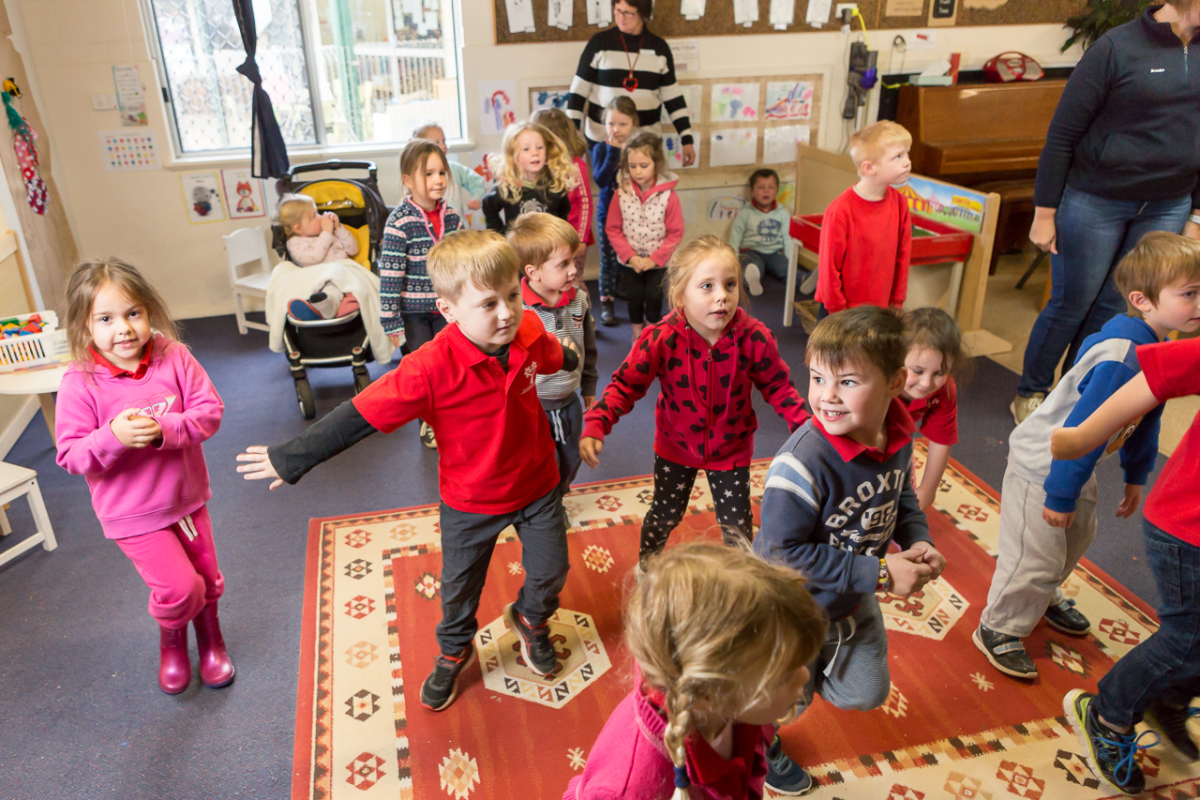

Outcome 5: Children are effective communicators
- Children interact verbally and non-verbally with others for a range of purposes
- Children engage with a range of texts and gain meaning from these texts
- Children express ideas and make meaning using a range of media
- Children begin to understand how symbols and pattern systems work
- Children use information and communication technologies to access information, investigate ideas and represent their thinking

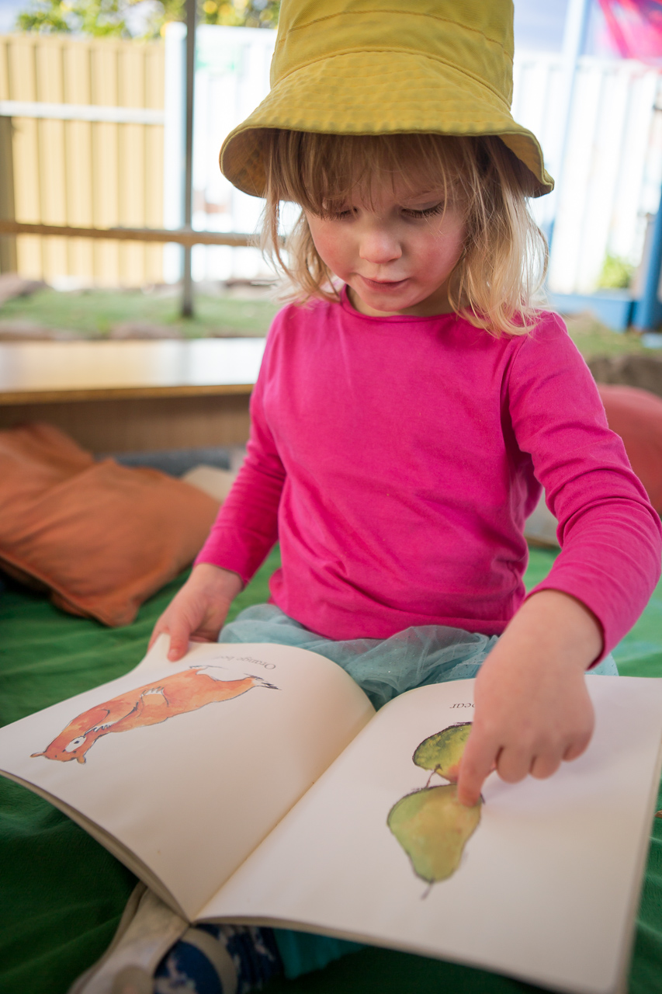

Texts:
things that we read, view and listen to and that we create in order to share meaning. Texts can be print-based, such as books, magazines and posters or screen-based, for example internet sites and DVDs. Many texts are multimodal, integrating images, written words and/or sound.

Attuned:
“Attunement includes the alignment of states of mind in moments of engagement, during which affect is communicated with facial expression, vocalisations, body gestures and eye contact”. (Siegel,1999)Outcome 5: Children are effective communicators

Children interact verbally and non-verbally with others for a range of purposes
This is evident, for example, when children:  - engage in enjoyable interactions using  verbal and non-verbal language  - convey and construct messages with purpose and confidence, building on home/family and community literacies  - respond verbally and non-verbally to what they see, hear, touch, feel and taste  - use language and representations from play, music and art to share and project meaning  - contribute their ideas and experiences in play, small and large group discussions  - attend and give cultural cues that they are listening to and understanding what is said to them  - are independent communicators who initiate Standard Australian English and home language conversations and demonstrate the ability to meet the listeners’ needs  - interact with others to explore ideas and concepts, clarify and challenge thinking,  negotiate and share new understandings  - convey and construct messages with purpose and confidence, building on literacies of home/family and the broader community  - exchange ideas, feelings and understandings using language and representations in play  - demonstrate an increasing understanding of measurement and number using vocabulary to describe size, length, volume, capacity and names of numbers  - express ideas and feelings and understand and respect the perspectives of others  - use language to communicate thinking about quantities to describe attributes of objects and collections, and to explain mathematical ideas  - show increasing knowledge, understanding and skill in conveying meaning in at least one language | Educators promote this learning, for example, when they:  - engage in enjoyable interactions with babies as they make and play with sounds  - are attuned and respond sensitively and appropriately to children’s efforts to communicate  - listen to and respond to children’s approximations of words  - value children’s linguistic heritage and with family and community members encourage the use of and acquisition of home languages and Standard Australian English  - recognise that children enter early childhood programs having begun to communicate and make sense of their experiences at home and in their communities  - model language and encourage children to express themselves through language in a range of contexts and for a range of purposes  - engage in sustained communication with children about ideas and experiences, and extend their vocabulary  - include real-life resources to promote children’s use of mathematical language

Outcome 5: Children are effective communicators

Children engage with a range of texts and gain meaning from these texts
This is evident, for example, when children:  - listen and respond to sounds and patterns in speech, stories and rhymes in context  - view and listen to printed, visual and multimedia texts and respond with relevant gestures, actions, comments and/or questions  - sing and chant rhymes, jingles and songs  - take on roles of literacy and numeracy users in their play  - begin to understand key literacy and numeracy concepts and processes, such as the sounds of language, letter-sound relationships, concepts of print and the ways that texts are structured  - explore texts from a range of different perspectives and begin to analyse the meanings  - actively use, engage with and share the enjoyment of language and texts in a range of ways  - recognise and engage with written and oral culturally constructed texts | Educators promote this learning, for example, when they:  - read and share a range of books and other texts with children  - provide a literacy-enriched environment including display print in home languages  and Standard Australian English  - sing and chant rhymes, jingles and songs  - engage children in play with words and sounds  - talk explicitly about concepts such as rhyme and letters and sounds when sharing texts with children  - incorporate familiar family and community texts and tell stories  - join in children’s play and engage children in conversations about the meanings of images and print  - engage children in discussions about books and other texts that promote consideration of diverse perspectives  - support children to analyse ways in which texts are constructed to present particular views and to sell products  - teach art as language and how artists can use the elements and principles to construct visual/musical/dance/media texts  - provide opportunities for children to engage with familiar and unfamiliar culturally constructed text
Add your own examples from your context:

Literacy:
in the early years literacy includes a range of modes of communication including music, movement, dance, story telling, visual arts, media and drama, as well as talking, reading and writing.

Outcome 5: Children are effective communicators

Children express ideas and make meaning using a range of media
This is evident, for example, when children:  - use language and engage in play to imagine and create roles, scripts and ideas  - share the stories and symbols of their own culture and re-enact well-known stories  - use the creative arts such as drawing, painting, sculpture, drama, dance, movement, music and storytelling to express ideas and make meaning  - experiment with ways of expressing ideas and meaning using a range of media  - begin to use images and approximations of letters and words to convey meaning | Educators promote this learning, for example, when they:  - build on children’s family and community experiences with creative and expressive arts  - provide a range of resources that enable children to express meaning using visual arts, dance, drama and music  - ask and answer questions during the reading or discussion of books and other texts  - provide resources that encourage children to experiment with images and print  - teach children skills and techniques that will enhance their capacity for  self-expression and communication  - join in children’s play and co-construct materials such as signs that extend the play and enhance literacy learning  - respond to children’s images and symbols, talking about the elements, principles, skills and techniques they have used in order to convey meaning
Add your own examples from your context:

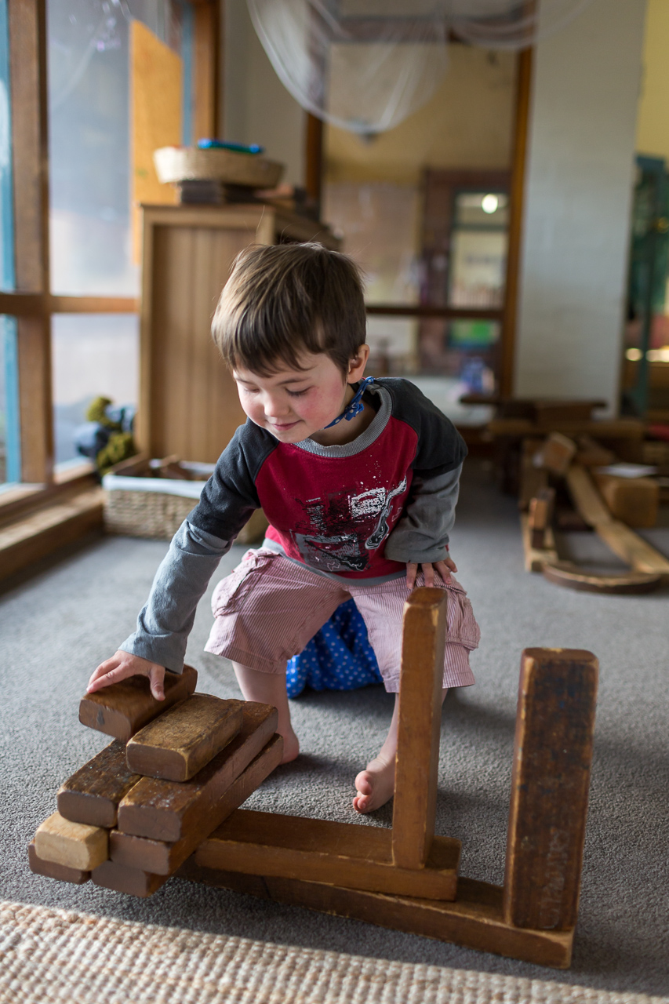
Outcome 5: Children are effective communicators

Children begin to understand how symbols and pattern systems work
This is evident, for example, when children:  - use symbols in play to represent and  make meaning  - begin to make connections between and see patterns in their feelings, ideas, words and actions and those of others  - notice and predict the patterns of regular routines and the passing of time  - develop an understanding that symbols are a powerful means of communication and that ideas, thoughts and concepts can be represented through them  - begin to be aware of the relationships between oral, written and visual representations  - begin to recognise patterns and relationships and the connections between them  - begin to sort, categorise, order and compare collections and events and attributes of objects and materials, in their social and natural worlds  - listen and respond to sounds and patterns in speech, stories and rhyme  - draw on memory of a sequence to complete a task  - draw on their experiences in constructing meaning using symbols | Educators promote this learning, for example, when they:  - draw children’s attention to symbols and patterns in their environment and talk about patterns and relationships, including the relationship between letters and sounds  - provide children with access to a wide range of everyday materials that they can use to create patterns and to sort, categorise, order and compare  - engage children in discussions about symbol systems, for example, letters, numbers, time, money and musical notation  - encourage children to develop their own symbol systems and provide them with opportunities to explore culturally constructed symbol systems
Add your own examples from your context:

Numeracy:
broadly includes understandings about numbers, patterns, measurement, spatial awareness and data as well as mathematical thinking, reasoning and counting.

Outcome 5: Children are effective communicators

Children use information and communication technologies to access information, investigate ideas and represent their thinking
This is evident, for example, when children:  - identify the uses of technologies in everyday life and use real or imaginary technologies as props in their play  - use information and communication technologies to access images and information, explore diverse perspectives and make sense of their world  - use information and communication technologies as tools for designing, drawing, editing, reflecting and composing  - engage with technology for fun and to make meaning | Educators promote this learning, for example, when they:  - provide children with access to a range  of technologies  - integrate technologies into children’s play experiences and projects  - teach skills and techniques and encourage children to use technologies to explore new information and represent their ideas  - encourage collaborative learning about and through technologies between children, and children and educators
Add your own examples from your context:

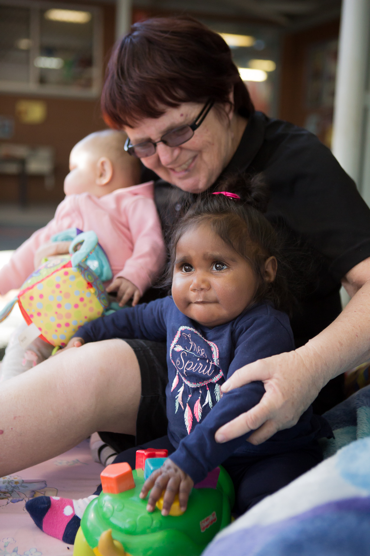
Glossary of Terms
Active learning environment: an active learning environment is one in which children are encouraged to explore and interact with the environment to make (or construct) meaning and knowledge through their experiences, social interactions and negotiations with others. In an active learning environment, educators play a crucial role of encouraging children to discover deeper meanings and make connections among ideas and between concepts, processes and representations. This requires educators to be engaged with children’s emotions and thinking. (Adapted from South Australian Curriculum Standards and Accountability (SACSA) Framework, General Introduction, pp10 & 11).
Agency: being able to make choices and decisions, to influence events and to have an impact on one’s world.
Attuned: “Attunement includes the alignment of states of mind in moments of engagement, during which affect is communicated with facial expression, vocalisations, body gestures and eye contact”. (Siegel, 1999).
Children: refers to babies, toddlers and three to five year olds, unless otherwise stated.
Community participation: taking an active role in contributing to communities.
Co-construct: learning takes place as children interact with educators and other children as they work together in partnership.
Communities: social or cultural groups or networks that share a common purpose, heritage, rights and responsibilities and/or other bonds. ‘Communities’ is used variously to refer, for example, to the community within early childhood settings, extended kinships, the local geographic community and broader Australian society.
Critical reflection: reflective practices that focus on implications for equity and social justice.
Curriculum: in the early childhood setting curriculum means ‘all the interactions, experiences, activities, routines and events, planned and unplanned, that occur in an environment designed to foster children’s learning and development’. [adapted from Te Whariki].
Dispositions: enduring habits of mind and actions, and tendencies to respond in characteristic ways to situations, for example, maintaining an optimistic outlook, being willing to persevere, approaching new experiences with confidence.
Early childhood settings: long day care, occasional care, family day care, Multi-purpose Aboriginal Children’s Services, preschools and kindergartens, playgroups, creches, early intervention settings and similar services.
Educators: early childhood practitioners who work directly with children in early childhood settings.
Inclusion: involves taking into account all children’s social, cultural and linguistic diversity (including learning styles, abilities, disabilities, gender, family circumstances and geographic location) in curriculum decision-making processes. The intent is to ensure that all children’s experiences are recognised and valued. The intent is also to ensure that all children have equitable access to resources and participation, and opportunities to demonstrate their learning and to value difference.
Intentional teaching: involves educators being deliberate, purposeful and thoughtful in their decisions and actions. Intentional teaching is the opposite of teaching by rote or continuing with traditions simply because things have ‘always’ been done that way.
Involvement: is a state of intense, whole hearted mental activity, characterised by sustained concentration and intrinsic motivation. Highly involved children (and adults) operate at the limit of their capacities, leading to changed ways of responding and understanding leading to deep level learning (adapted from Laevers, 1994).
Children’s involvement can be recognised by their facial, vocal and emotional expressions, the energy, attention and care they apply and the creativity and complexity they bring to the situation. (Laevers) A state of flow Csikszentmihayle cited in Reflect, Respect, Relate (DECS 2008).
Learning: a natural process of exploration that children engage in from birth as they expand their intellectual, physical, social, emotional and creative capacities. Early learning is closely linked to early development.
Learning framework: a guide which provides general goals or outcomes for children’s learning and how they might be attained. It also provides a scaffold to assist early childhood settings to develop their own, more detailed curriculum.
Learning Outcome: a skill, knowledge or disposition that educators can actively promote in early childhood settings, in collaboration with children and families.
Learning relationships: relationships that further children’s learning and development. Both the adult and the child have intent to learn from each other.
Literacy: in the early years literacy includes a range of modes of communication including music, movement, dance, story telling, visual arts, media and drama, as well as talking, reading and writing.
Numeracy: broadly includes understandings about numbers, patterns, measurement, spatial awareness and data as well as mathematical thinking, reasoning and counting.
Pedagogies: practices that are intended to promote children’s learning.
Pedagogy: early childhood educators’ professional practice, especially those aspects that involve building and nurturing relationships, curriculum decision-making, teaching and learning.
Play-based learning: A context for learning through which children organise and make sense of their social worlds, as they engage actively with people, objects and representations.
Reflexivity: children’s growing awareness of the ways that their experiences, interests and beliefs shape their understanding.
Scaffold: the educators’ decisions and actions that build on children’s exisitng knowledge and skills to enhance their learning.
Spiritual: refers to a range of human experiences including a sense of awe and wonder, and an exploration of being and knowing.
Technologies: includes much more than computers and digital technologies used for information, communication and entertainment. Technologies are the diverse range of products that make up the designed world. These products extend beyond artefacts designed and developed by people and include processes, systems, services and environments.
Texts: things that we read, view and listen to and that we create in order to share meaning. Texts can be print-based, such as books, magazines and posters or screen-based, for example internet sites and DVDs. Many texts are multimodal, integrating images, written words and/or sound.
Transitions: the process of moving between home and childhood setting, between a range of different early childhood settings, or from childhood setting to full-time school.
Wellbeing: Sound wellbeing results from the satisfaction of basic needs - the need for tenderness and affection; security and clarity; social recognition; to feel competent; physical needs and for meaning in life (adapted from Laevers 1994). It includes happiness and satisfaction, effective social functioning and the dispositions of optimism, openness, curiosity and resilience.

Bibliography
Bailey, D. B. (2002). Are critical periods critical for early childhood education? The role of timing in early childhood pedagogy. Early Childhood Research Quarterly, 17, 281-294.
Brooker, L., & Woodhead, M. (Eds.). (2008). Developing positive identities. Milton Keynes: The Open University.
Fleer, M., & Raban, B. (2005). Literacy and numeracy that counts from birth to five years: A review of the literature. Canberra: Department of Education, Science and Training.
Carr,M. (2001). Assessment in early childhood settings: learning stories. London: Paul Chapman.
Department of Education and Children’s Services (2008). Assessing for Learning and Development in the Early Years using Observation Scales: Reflect Respect Relate, Adelaide: DECS Publishing.
Department of Education Training and Employment (2001). South Australian Curriculum, Standards and Accountability Framework, Adelaide: DETE Publishing.
Gammage, P. (2008). The social agenda and early childhood care and education: Can we really help create a better world? Online Outreach Paper 4. The Hague: Bernard van Leer Foundation.
Grieshaber, S. (2008). Interrupting stereotypes: Teaching and the education of young children. Early Education and Development, 19(3), 505-518.
Hertzman, C. (2004). Making early child development a priority: Lessons from Vancouver. Ottawa: Canadian Centre for Policy Alternatives.
Laevers, F. (1994). Defining and assessing quality in Early Childhood education. Studia Paedagogica. Leuven: Leuven University Press.
Lally, R. (2005). The human rights of infants and toddlers: A comparison of childcare philosophies in Europe, Australia, New Zealand and the Unites States. Zero to Three 43-46.
Mac Naughton, G. (2003). Shaping early childhood: Learners, curriculum and contexts. Maidenhead: Open University Press.
Martin, K. (2005). Childhood, lifehood and relatedness: Aboriginal ways of being, knowing and doing. In J. Phillips & J. Lampert (Eds.), Introductory indigenous studies in education: The importance of knowing (pp. 27-40). Frenches Forest, Sydney: Pearson Education Australia.
Ministry of Education, (1996). Te Whãriki: He Whãriki Mãtauranga mõ ngã Mokopuna o Aotearoa/Early Childhood Curriculum. Wellington: Learning Media.
Moss, P. (2006). Early childhood institutions as loci of ethical and political practice. International Journal of Educational Policy, Research and Practice: Reconceptualizing Childhood Studies, 7, 127-136.
OECD. (2006). Starting Strong II: Early Childhood Education and Care: OECD.
Petrie, P., Boddy, J., Cameron, C., Heptinstall, E., McQuail, S., Simon, A., et al. (2008). Pedagogy - A holistic, personal approach to work with children and young people, across services. London: Thomas, Coram Research Unit, Institute of Education, University of London.
Queensland Department of Education, Training and the Arts, 2008, Foundations for Success - Guidelines for Learning Program in Aboriginal and Torres Strait Communities, Queensland Governement.
Queensland Studies Authority. (2006). Queensland early years curriculum guidelines. Brisbane: The State
of Queensland.
Rogoff, B. (2003). The cultural nature of human development. Oxford: Oxford University Press.
Shonkoff, J., & Phillips, D. K. (2000). From neurons to neighbourhoods: The science of early childhood development. Washington, DC: National Academies Press.
Siegel DJ, 1999:88, Developing Mind, Guilford Press, New York.
Siraj-Blatchford, I., & Sylva, K. (2004). Researching pedagogy in English pre-schools British Educational Research Journal, 30(5), 712-730.
Sylva, K., Melhuish, E., Sammons, P., Siraj-Blatchford, I., & Taggart, B. (2004). The Effective Provision of
Pre-school Education: The final report. London: DfES Sure Start Publications & The Institute of Education.
Uprichard, E. (2007). Children as ‘being and becomings’: Children, childhood and temporality. Children & Society, 22, 303-313.
Wood, E. (2007). New directions in play: Consensus or collision. Education 3-13, 35(4), 309-320.
Woodhead, M., & Brooker, L. (2008). A sense of belonging. Early Childhood Matters (111), 3-6.

